GUJARAT TECHNOLOGICAL UNIVERSITY

Chandkheda, Ahmedabad

Affiliated

[Sardar Patel College Of Engineering]



A Report of

[Summer Internship]

(Awards House)

Under subject of

Summer Internship (3170001)

Semester – VII (Information Technology)

Submitted by:

Vishwas R Acharya & 181240116001

(Prof. Nirali Darji)

(Prof. Nikul Patel)

Academic Year

2021-22

**[Sardar Patel College Of Engineering]**

**Certificate**

Date:

This is to certify that **the [Summer Internship] Report “Awards House”** has been carried out by **Vishwas R Acharya (181240116001)** under my guidance in partial fulfillment of the degree of Bachelor of Engineering in **Information Technology** (7thSemester) at College name during the academic year 2021-22.

(Prof. Nirali Darji) (Nirmal Rabari) (Prof. Nikul Patel)

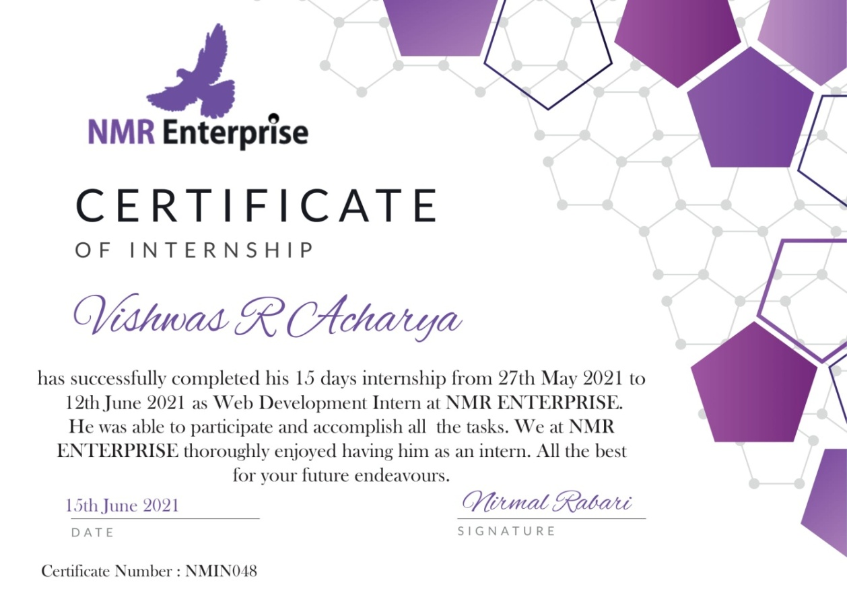

**ACKNOWLEDGEMENT**

The satisfaction that accompanies the successful completion of any task would be incomplete without the mention of people whose ceaseless corporation made it possible, whose constant guidance and encouragement grown all effort with success.

Our sincere thanks to our **Prof. Nirali Darji, Nirmal Rabari and Prof. Nikul Patel** for providing valuable guidance throughout our project work. Whenever we were confused about anything, they were always there to help us.

We are thankful to Gujarat Technological University to giving the opportunity for assigning this **[Summer Internship]** work.

**Vishwas Acharya (181240116001)**

**CONTENT**

|  |  |  |  |
| --- | --- | --- | --- |
| Title Page | | | I |
| Certificates | | | II |
| Acknowledgement | | | III |
| Content | | | IV |
| List of Figures | | | V |
| List of Table | | | VI |
| 1 |  | Introduction | 1 |
|  | 1.1 | Project Summery /Introduction of [Summer Internship/Mini Project Name/Specification/Seminar] | 1 |
|  | 1.2 | Aim and Objectives | 1 |
|  | 1.3 | Project Requirement | 2 |
|  | 1.4 | Tools & Technologies | 2 |
| 2 |  | System Analysis | 3 |
|  | 2.1 | Existing System | 3 |
|  | 2.2 | Proposed System | 3 |
| 3 |  | Implementation | 4 |
|  | 3.1 | Functional | 5 |
|  | 3.2 | Non Functional | 6 |
| 4 |  | Outcomes | 7 |
|  | 4.1 | Conclusion | 7 |
|  | 4.2 | Future Enhancement | 7 |
| 5 |  | Bibliography (Include only website links or book name magazine name) | 8 |
|  |  |  |  |

**Project introduction**

My project name is **Awards House** and the concept of that project is to lists best Start-Ups, NGOs and websites of India and allows users to rate and review them.

It Provides recognition and awards to the top rated companies and organizations in the three respective categories.

In this Project we worked on different areas like Front-end development , Back-end development, UI/UX design, graphics, Content and business development of the website.

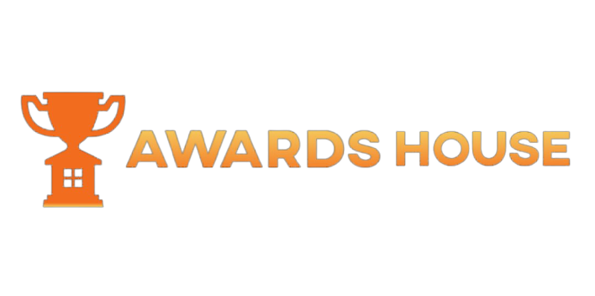

**Introduction of Summer Internship**

It was a 15 day internship starting from 28th MAY, 2021 - 12th JUNE, 2021. The name of the company is NMR Enterprise which basically provides the IT services to business for going online with growths. It's work involves developing websites, graphics designing and mobile applications for business.

The Key Points which were covered during this internship are given below:

* **Personal Growth:**  Morning Meetings/Webinars between 7AM to 8AM.
* **Technical Growth:** Working on Live Project with team.
* **Management:** Communication and team work of 20 members.
* **Guidance:** Our work was guided by HR itself and allotted mentor.

This were the key points which were mainly focused on.

**Aim and Objectives**

Our aim is to make a fully functional website before completion of our internship, and the name of the project was as I mentioned **Awards House**.

Our Objectives are to achieve a kind of website which describes our goal which is to provides recognition and awards to the top rated companies and organizations.

Also where user can give rating to any particular category, for example NGO. Hence it can get recognition based on the ratings and reviews.

**Project Requirement**

To achieve this kind of website, we require following things:

* Front-end Development
* Back-end Development
* Graphic Designing
* Content
* Research and Development

As we had 20 members in our team, we divided our work among ourselves, according to the individual skills and interest.

**Tools & Technologies**

As above mentioned requirement, so to fulfill that requirement, we used following tools and technologies to develop this website:

1. UI Design

* Figma

1. Tool

* Visual Studio Code

1. Front-end Coding

* Html
* Css
* Javascript
* Bootstrap

1. Back-end Coding

* Php

**System Analysis**

In order to make a project with this vision we analyzed and found a following things that we require to add in our project.

* star rating system
* Reviews
* Login/Logout Model
* Dashboard

**Existing System**

As above mentioned are our requirements of making this website, so from above requirements we have few existing system that we can use in our project.

* Rating System
* Login/Logout Model

So to make this project working we used bootstrap and other things to achieve fast results.

**Proposed System**

So as we started working on this project we used all the resources which can help us in making this project, And few of them are mentioned below :

* Admin and User Panel
* 3 Categories
* Live Rating
* Reviews

Hence this are the things that we worked on.

**Implementation**

We have made two panels, which is User's website where people can go and give rating, nomination, and all. All the Implementation is finished expect the backend connection. Some of the screenshots are given below :

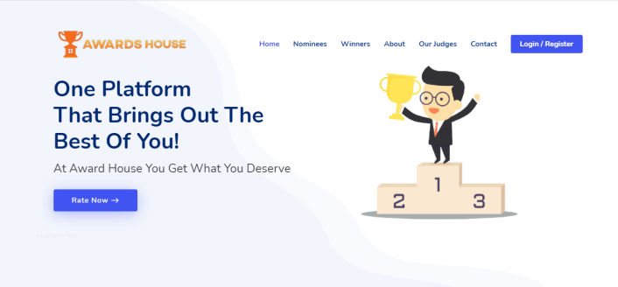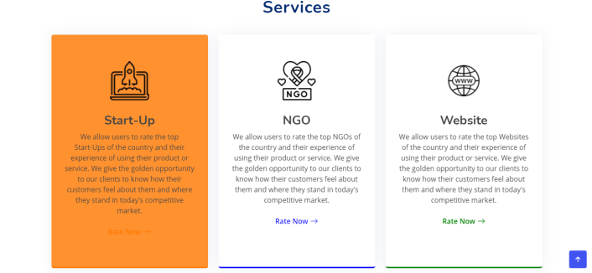  
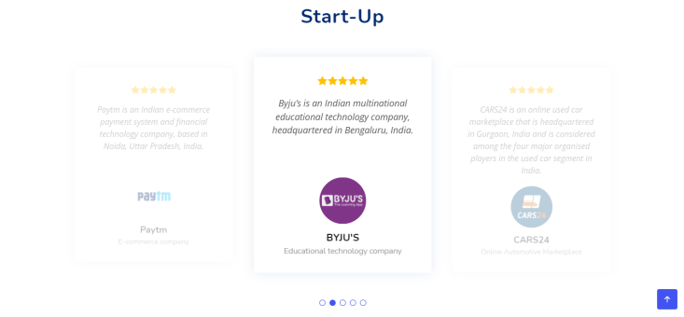

Hence this are the screenshots of our website

named **Awards House.**

**Functional**

The functional part of our website are given below with the screenshots.

**Home Page :**

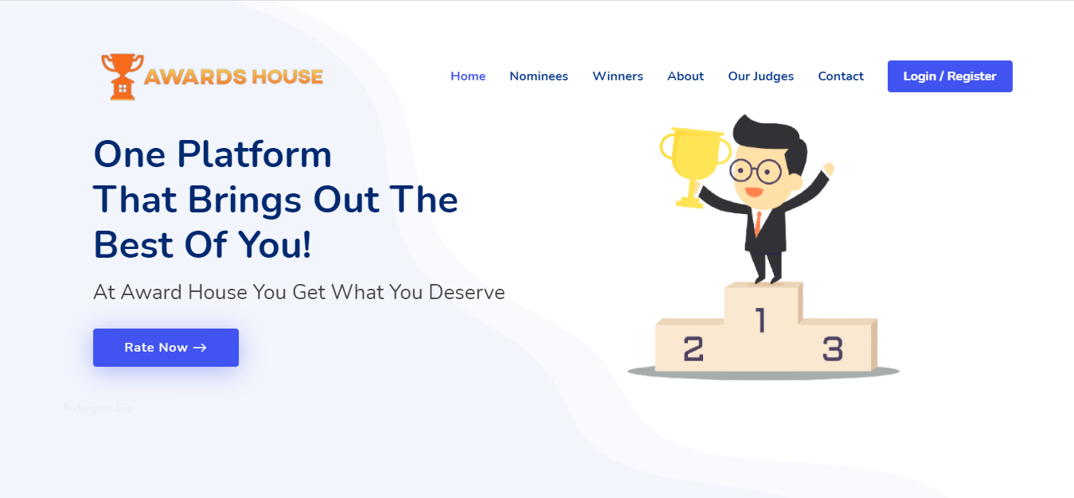

**Services Page :**

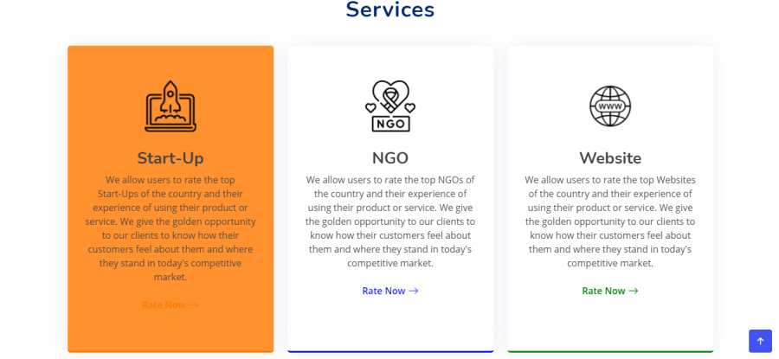

**Rating Page :**

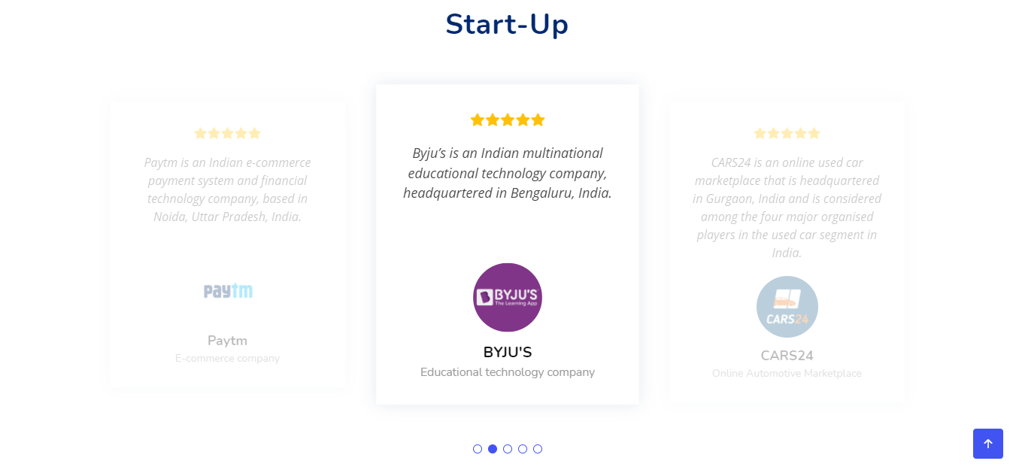

**Admin Dashboard :**

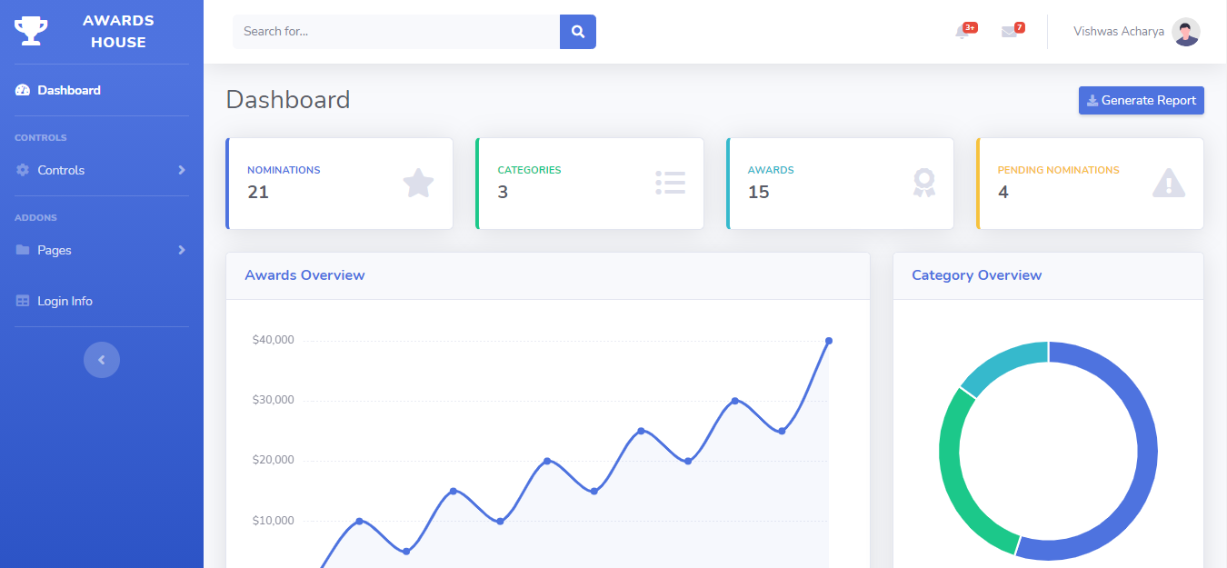

**Services Dashboard :**

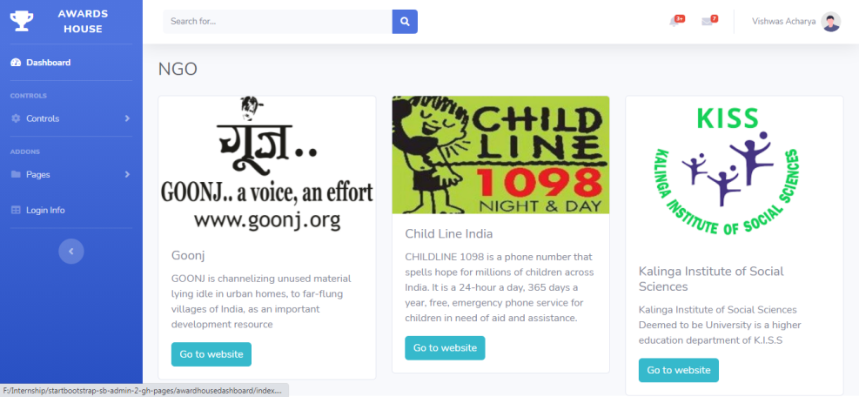

**Non - Functional**

The Non - Function part of our website are the backend part, We connected our website using pHp and MY-SQL but unfortunately some tabs of our dashboard website are not working. So that part of our website is not working.

Hence, this are the implementation's of our website.

**Outcomes**

At the of the completion of the website and internship we were done with our front-end part of our website.

As given screenshots the implementation of our website is complete, but because of no back-end we haven't hosted the final product.

**Conclusion**

We finished working on a fresh idea named **Awards House** which was a perfect start for us to work on live projects which we'll encounter in our future projects. And hence, as we've seen that Awards House is a website where people can come and give ratings and reviews to startups and website's who are not getting any recognition from other platforms, hence this is the main goal of making this website. And by the means of future projects is, that whatever projects we will do when we'll work on big projects like zomato or urban clap. Also, We were guided by Nirmal Sir (CEO of NMR Enterprise) himself in this project and side by side he gave us professional (How companies works and how the process of working on projects starting from idea to deployment) and personal guidance (How to improve communication and how to make more connection) or road map of our upcoming projects and turning points. Though our project was 70% completed and the reason 70% because the backend part of the website was incomplete from the admin website hence 30% was not finished, but still it was a perfect learning opportunity.

**Future Enhancement**

As of for now, we have made our website just for ratings and recommendation with 3 categories included, but for future we have a plan for adding more categories and sub-categories like - Best CSS Design website, Best Content Offering Website, Top Books, and much more. Also we have a plan on adding judges those who want to contribute their judging experience to our website.

Hence, this is the future scope we have decided to work on for now.

**Bibliography**

<http://localhost/awardhouse>

<http://localhost/awardhousedashboard>